**Ideas:**

The Micro mouse project was part of 2014’s computer systems project, and as such, we did not have to put effort into what we were going to build. Since it was mandatory to build the HCS12 micro mouse at the time, we didn’t have to come up with different ideas since our main focus was the mouse. What was up to us was how we got to design our mice. While the main functionality would be the same for all the mice, design choices such as chassis design and code specifications were up to us. We were then presented with a new task. Not only did our mouse have to solve a maze, but it also had to incorporate a mobile application and a Bluetooth feature.

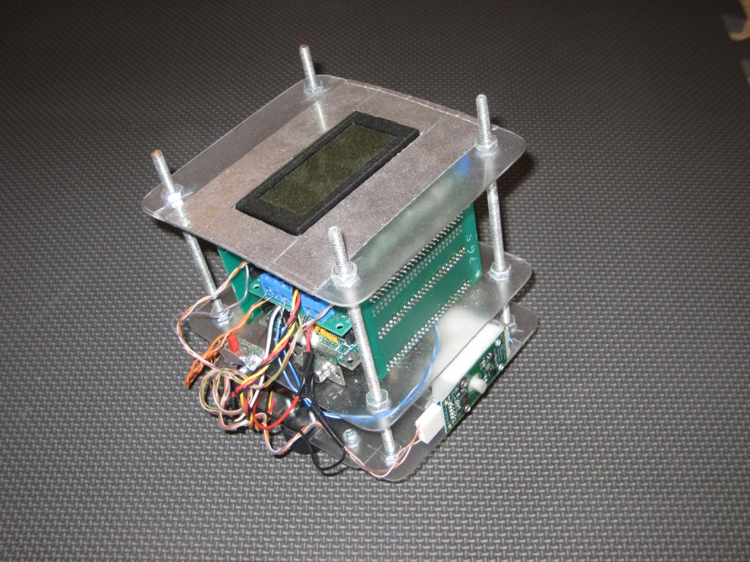

By looking up other mice that used HCS12 hardware such as the one above, we came to the conclusion that the smaller the frame, the faster the mouse would be. With this in mind, we went for a minimalist approach in terms of the chassis

We began our design for the mouse based off of the maze it would solve. The specifications for the maze itself at the time had the following characteristics:

* *18 cm x 18 cm size of the maze square (see sample boards)*
* *The "target" will be designated by a white square of electrical tape in the center of a square somewhere in the maze. The square will be 6cm by 6cm.*
* *Note maze accuracy: 'The dimensions of the maze shall be accurate to within 5% or 2 cm, whichever is less'*

So by this point, we had come up with a generic design for the chassis itself. What we needed to work on was the code for the HCS12, and the phone app/Bluetooth implementations.

**Bill of materials/Cost estimate/Budget:**

Before we began ordering parts, we had to make sure what ordered exactly what was needed. So after creating a list of parts, we came up with a cost estimate of $274.90. This would cover all our expenses.

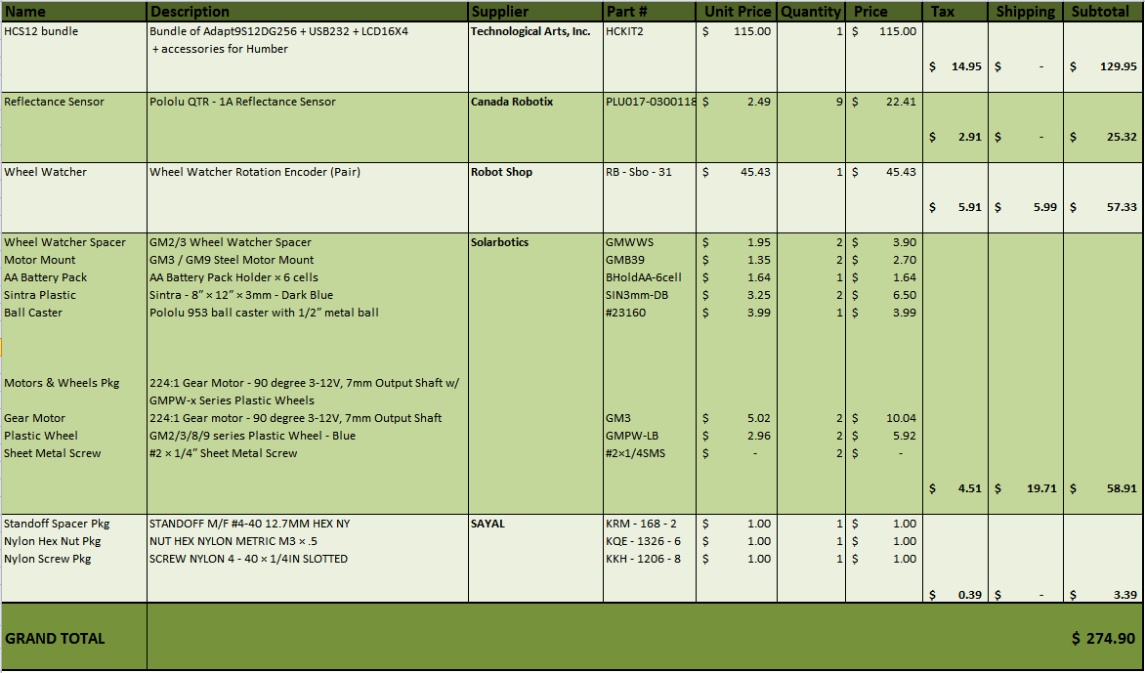

After we ordered the materials, it was time to start putting it together. Some of pieces had already came ready, but for the most part we had to solder parts into place.

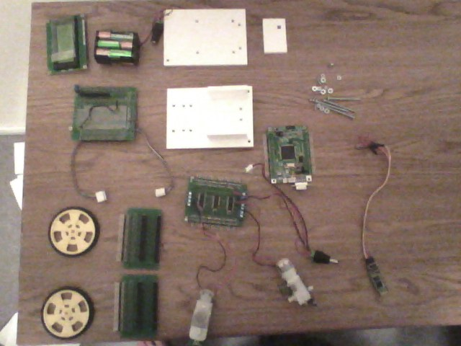

**Parts information:**

The HCS12 hardware was obtained through Humber College. After obtaining it, there was a few modifications that had to be made before we could start implementing code. For instance, the HSC12 had chips and transistors that needed to be soldered. The connections that held the hardware in place also had to be soldered. One of the sides for the HCS12 needed two resistors to be soldered into the holes shown below (right image). This was needed so that a proper connection could be established throughout the entire board. There was also a wire that had to be connected as shown on the image bellow (black wire in left image), as well as a physically removing a connection on the board itself shown in the red outline (we had to scratch it out).

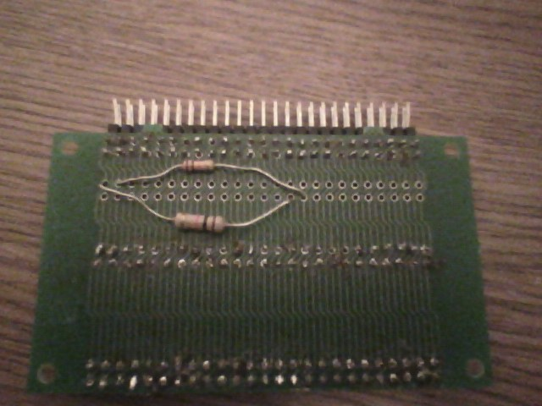

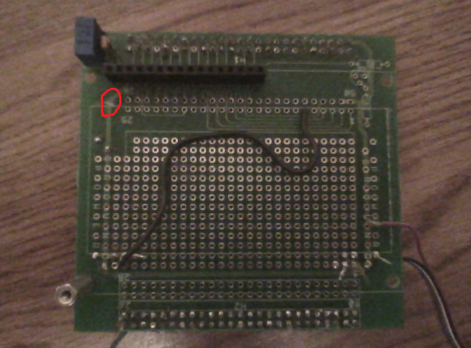

The Bluetooth module came late in the development process, but we still managed to configure it with the HCS12. When connecting it to a phone, a default password was entered, and we were able to sync it.

**Work breakdown**

First, we began with the construction of the mouse. After we configured the default configurations mentioned above, we were ready the begin construction. Our first goal was to assemble the HCS12 hardware.

The connections for power was one of the first things we soldered. Since we couldn’t really modify it after we put it together, we had to make sure everything was in its proper place. After placing our encoders onto the motors, we made the connected them to what would eventually be the power connections.

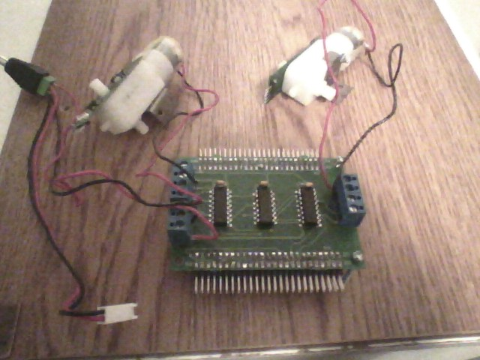

Next, our encoder connections needed to be soldered into place.

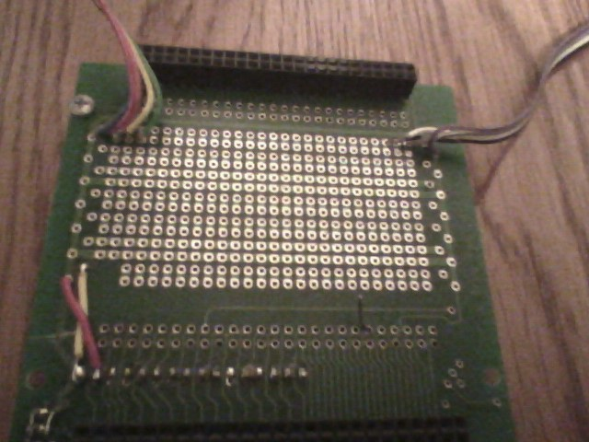

At this point, all we had to do was place thee HCS12 pieces together, and our HCS12 hardware production was complete.

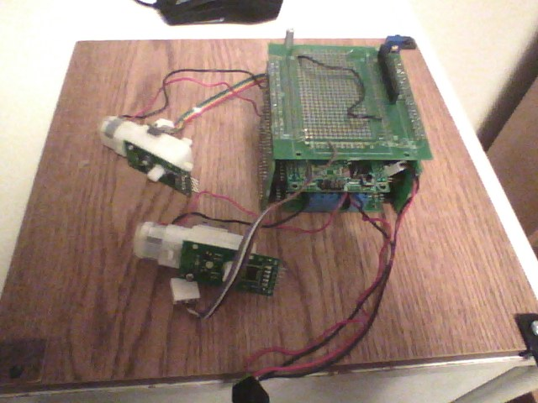

As mentioned before, we had designed our mouse to be tailored to the maze design. And so with that in mind, we created a blueprint in which we were able to laser cut onto our material.

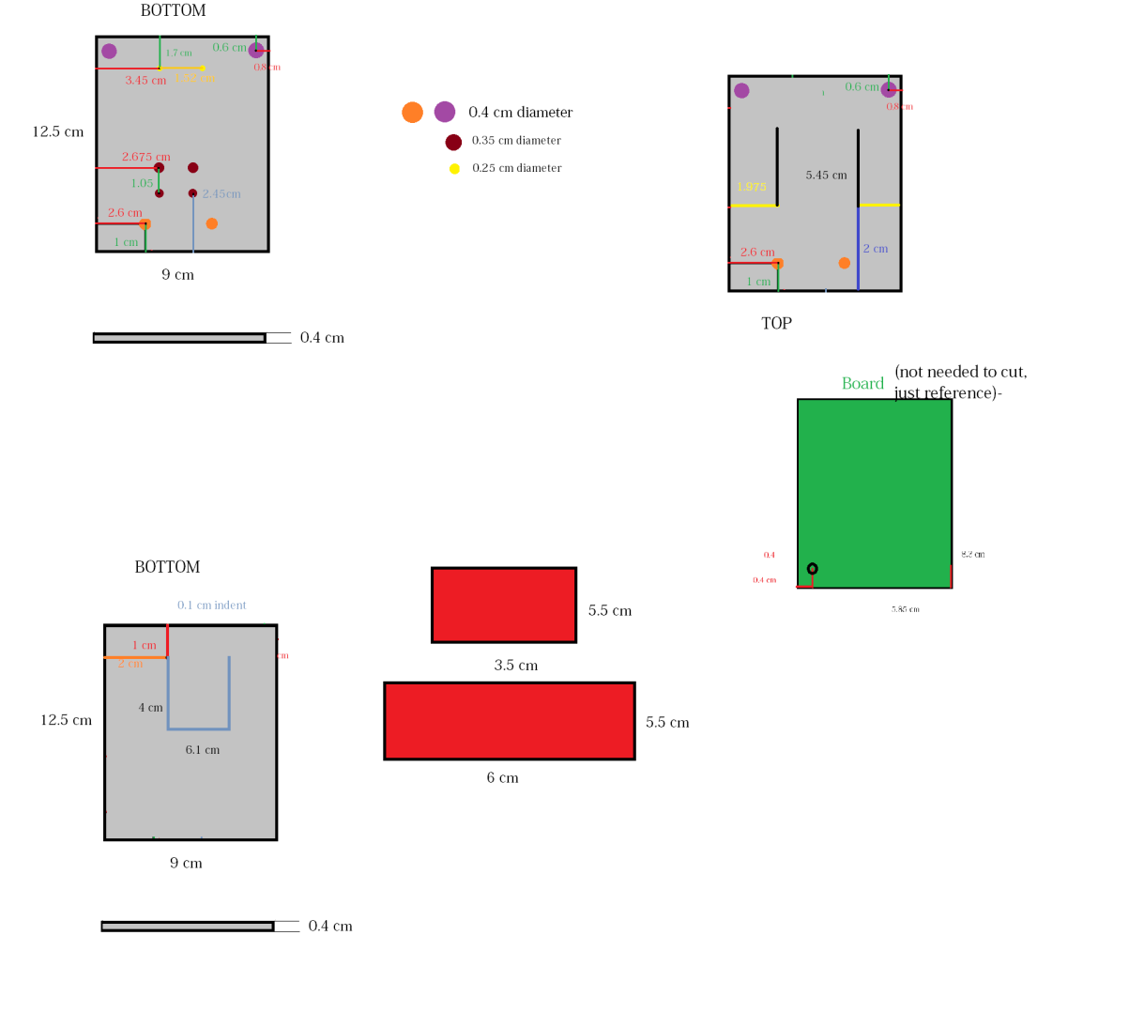

With the chassis completed, we were finally able to mount the HCS12 and motors onto it. One of the last steps was to place the Bluetooth Module onto the board. Using the correct ports according to our code, we soldered the correct wires to their appropriate places.

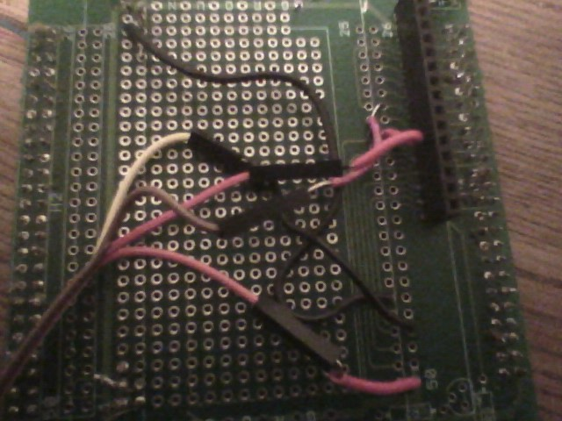

After that, our mouse production was complete.

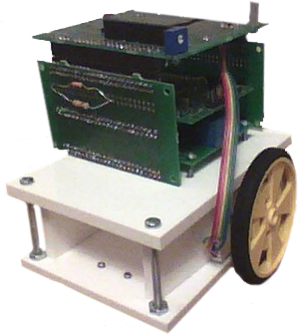

The code we used to move the mouse was all referenced from our teacher’s code. We did have to modify some parts of it such as the pulse width modulation and the ports (which is documented inside the code), so for the most part, the code remained the same. We used two main applications throughout this project: CodeWarrior and AsmIDE. CodeWarrior allowed us to code assembly and C language together, while AsmIDE allowed us the load the code into the HCS12. All the codes that we used are located inside the GitHub folder named System Software.

To build a phone application that could communicate to out Bluetooth module took some research. As most micro mouse’s are not build with HCS12, we had to improvise. Following the instructions from an Arduino website, we were able to build a phone app that could do what we wanted. The website that we used is included in the reference section, and the AIA file for the app is located inside the System Software folder.